

**9**` 

Homeroom Guidance

**Quarter 1 – Module 1: My Study Habits Version 4.0**

#### Name: Paul Gerald D. Pare

#### Section: Adenine

#### Homeroom Guidance Self-learning Module – Grade 9

Quarter 1 Module 1: My Study Habits Version 4.0

2020 Edition

**The Intellectual Property Code of the Philippines** states that “No copyright shall subsist in any work of the Government of the Philippines. However, prior approval of the government agency or office wherein the work is created shall be necessary for exploitation of such work for profit. Such agency or office may, among other things, impose as a condition the payment of royalties.”

Borrowed materials (e.g., texts, illustrations, musical notations, photos, and other copyrightable, patentable contents) included in this learning resource are owned by their respective copyright and intellectual property right holders. Where applicable, DepEd has sought permission from these owners specifically for the development and printing of this learning resource. As such, using these materials in any form other than agreed framework requires another permission and/or licensing.

No part of this material, including its original and borrowed contents, may be reproduced in any form without written permission from the Department of Education.

#### Recommended Entry:

Department of Education. *Homeroom Guidance Grade 9 Self-learning Module 1: My Study Habits Version 4.0.* Manila: Department of Education Central Office, 2020.

Published by the Department of Education Secretary: Leonor Magtolis Briones Undersecretary: Diosdado M. San Antonio Assistant Secretary: Alma Ruby C. Torio

**Development Team**

**Writers:** Crissa P. Zamoranos, Madel R. Mabanes

**Grade Level Coordinator**: Melanie O. Mandin

**Editors:** Mark Anthony Bercando, Jona Kristen Valdez, Melynda Andres

**Illustrators:** Jayson R. Gaduena, Jerichko Bauer L. Laroco**,** Marieto Cleben V. Lozada, Mark Dave M. Vendiola, Katrina S. Padilla, Grace Ann A. Caldito, and Cherry Amor

R. Laroza

**Layout Artists:** Jacqueline E. Libut and Cherry Amor R. Laroza

**Management Team:**

* Bureau of Curriculum Development: Jocelyn DR. Andaya,*Director IV,* Ma. Isabel Victorino, *CSDD Chief,* Mark Anthony Bercando,*Supervising EPS,* Jona Kristen Valdez, Melynda Andres, *Senior EPS*
* Bureau of Learning Resources

**Homeroom Guidance Grade 9 Quarter 1 – Module 1:**

**My Study Habits Version 4.0**

Gabay sa Magulang/Tagapag-alaga

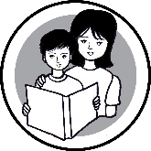

Nagdulot ng napakaraming pagbabago sa pamumuhay ng bawat Pilipino ang pandemyang nararanasan ng buong mundo. Sa gitna nito, ang Department of Education ay kaisa ng inyong tahanan upang maipagpatuloy ang edukasyon ng lahat ng mag-aaral sa buong Pilipinas. Dalawa sa mga pamamaraang ito ang paghahanda ng Leaning Continuity Plan at ng Most Essential Learning Competencies (MELCs).

Sa taong ito, inihanda ang Homeroom Guidance MELCs na naglalayong matulungan ang inyong mga anak upang maipagpatuloy ang pagkatuto sa kabila ng mga pagbabagong dulot ng pandemya. Naglalayong maituro ng Homeroom Guidance (HG) ang mga kasanayan sa buhay o life skills sa pamamagitan ng self- learning modules. Nakatuon ito sa tatlong mahahahalagang domeyn—ang academic, personal-social at career development. Binigyang-pokus sa Homeroom Guidance MELCs ang mga gawaing makatutulong sa lahat ng mga mag-aaral na magkaroon ng Rasyunal na Pag-iisip (Rational Thinking), Malusog/Maayos na Pagkilos (Healthy Behavior) at Positibong Disposisyon (Positive Disposition) na higit na kailangan sa panahong ito.

Malaki ang gampanin ng mga magulang upang mapagtagumpayan ang mga gawaing nakalatag dito. Kakailanganin ng mag-aaral ang inyong patnubay at gabay sa modyul na ito. Kung kaya, hinihingi ng DepEd ang inyong suporta na makatutulong upang mapagtagumpayan ng mag-aaral ang mga hamon sa buhay, maisakatuparan ang mga inaasahang gawain at higit sa lahat, matutuhan ang mga kasanayan sa buhay na kailangan nilang taglayin sa yugtong ito.

## Introductory Message

### For the learner:

As part of examining your life while trying to adjust to the new normal, it is important to evaluate your strength and weaknesses. Doing it will help you to the adjustments that you will need for the next stage of your life.. This could help you understand the things that happen around you and to effectively deal with different challenges.

Work on the tasks seriously; seek help if you believe you need to. Remember, in life there are things that we cannot control. There will be negative events that will challenge our positive dispositions. However, let us not be disheartened; we have the means on how to overcome it. You have that in you! Embark on this journey of overcoming your weaknesses and optimizing your strengths to attain your better version.

This self-learning module has six interactive tasks such as:

 **Let’s Try This** – which will help you to get ready to learn;

**Let’s Explore This** – which will guide you towards what you need to learn;

### **Keep in Mind** – which will give you the lessons that you need to learn and understand;

**You Can Do It** – which will help you apply the lessons learned in daily activities;

 **What I Have learned** – which will test and evaluate your learning;

**Share Your Thoughts and Feelings** – which will help you express your thoughts, opinions and feelings.

### Make sure to read, think, follow, and enjoy every task that you are asked to do.

Have fun! Stay safe and healthy!

**MY STUDY HABITS VERSION 4.0**

**MODULE**

**1**

**Learning Objectives**

At the end of this module, you are expected to:

1. explain how your learning style affects your study habits;
2. assess your study skills needed in effective facilitation of learning; and
3. cite ways on how to strengthen your effective study habits.

**Period**: Week 1 of 1st Quarter

**Suggested Total Time Allotment:** 60 Minutes

#### Materials Needed:

* Clean sheets of paper/bond papers
* Study Skills Assessment Worksheet
* Coloring materials, if available

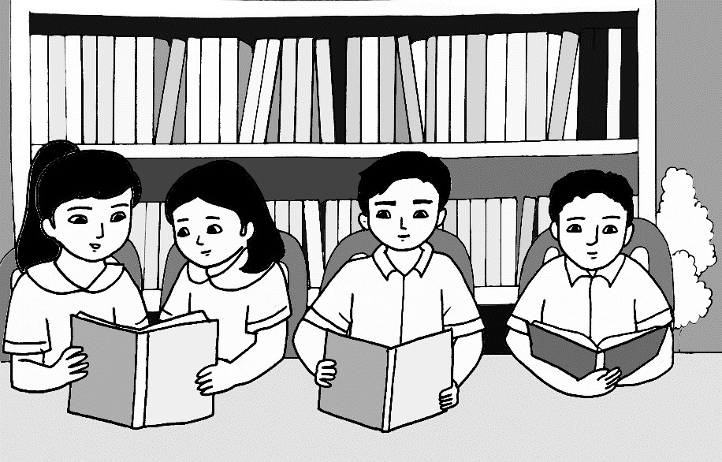

**Introduction**

The pandemic situation that all of us are facing at the moment may change how you learn but it will not hold back your education in any way. You will continue to gain knowledge and acquire skills, perhaps in an unconventional method and environment, but you can still learn.

As a learner, you will get to see the significant connection between your learning style and your study habits. You will also be more deeply aware of your study habits by answering a Study Skills Questionnaire that will help you assess the level of your study skills. You know by now that developing effective study habits is one great way of ensuring academic achievement.

# Let’s Try This

**Suggested Time Allotment:** 5 minutes

## *“*Isipin Mo, Iguhit Mo—Magagawa Mo!*”*

1. Think of one activity that you wanted to do by yourself for a long time now.
2. On a clean sheet of paper/bond paper, try to convey the idea through drawing.
3. It is all right if you need additional time to translate your idea through drawing. Remember that your creativity is limitless.
4. Below your drawing, write your answers to the processing questions.

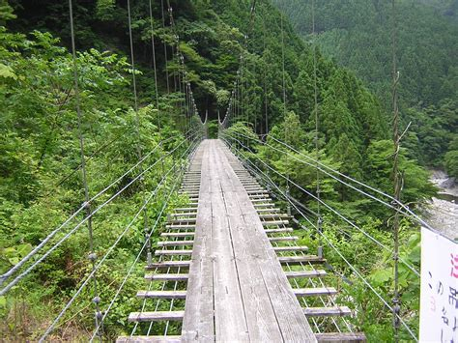

*Processing Questions:*

1. What activity did you draw? Why? Walking in a bridge on top of a river in a tropical forests.
2. Was it easy to translate your idea into drawing?Yes but it is hard to achieve better graphics/illustration without art skills.

# Let’s Explore This

**Suggested Time Allotment:** 5 Minutes

## Rank Your Senses

*In the past eight years of your student life, try to analyze yourself in terms of the senses you usually used to learn. In a scale of 1 to 5, 1 as the lowest and 5 as the highest, rank your most used senses during learning session.*

|  |  |  |  |  |  |
| --- | --- | --- | --- | --- | --- |
| **LEARNING STYLE** | **RANK** | | | | |
| **1** | **2** | **3** | **4** | **5** |
| **Visual** – learning with pictures and images |  |  |  |  |  |
| **Auditory** – learning with sounds and music |  |  |  |  |  |
| **Kinesthetic** – learning with bodily movements |  |  |  |  |  |
| **Logical** – learning through reasoning |  |  |  |  |  |
| **Verbal** – learning through words |  |  |  |  |  |
| **Social** - learning with other people |  |  |  |  |  |
| **Solitary** – learning through feelings |  |  |  |  |  |

**Processing Questions:**

* 1. What have you noticed with your answers? I noticed that Logical learning style always works for me, because I would know the reason behind that name or term.
  2. What convinced you to have such answers? The speed of which I could learn by a style. For example I could remember and think better if I knew the reason behind that term.
  3. Could you recall the most recent experience where your rank 1 was evident? Yes, in our grade 8 session or class in ValEd/Esp, we watched a video about helping each other.

**Keep in Mind**

**Suggested Time Allotment:** 20 Minutes

The activity showed seven (7) different types of learners and while most of you have a combination of different learning styles, you can say that you have a preferred method of processing information. Each learner has a dominant learning style.

Since you are presently learning from home and not attending face-to-face classes, it is all the more important for you to get acquainted with the different learning styles, strengthen your dominant or preferred learning style, and cultivate good study habits connected to the said learning styles.

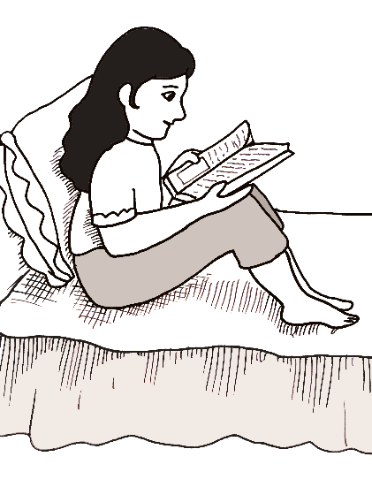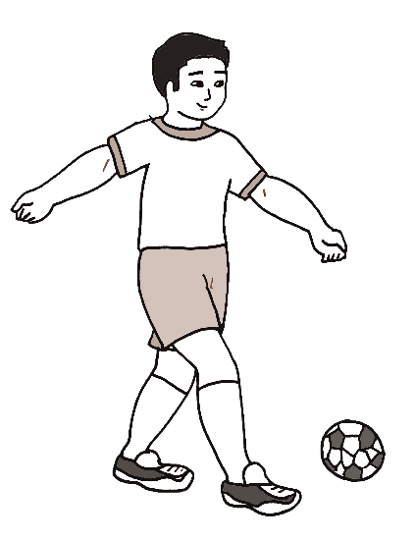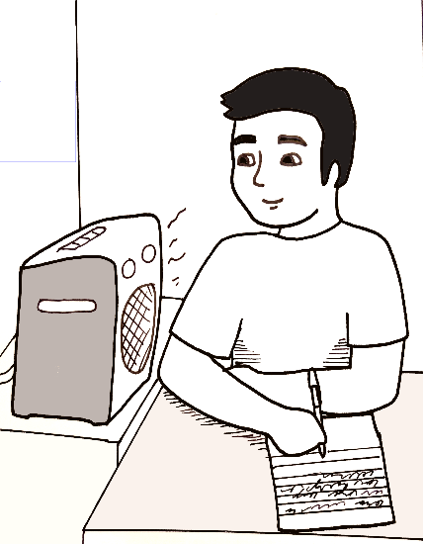

There are many types of learning styles. It would help if you can identify yours so you can be mindful how you learn best.

* **Visual** is a learning style where students acquire knowledge when the lessons are presented in pictures, images, directions and diagrams. This is often called as spatial learning style.
* **Auditory** is a learning style where students learn best when audio, music or sounds are being employed in the learning session.
* **Kinesthetic** is a learning style where students are keen on utilizing their sense of touch and hands to learn well. Kinesthetic learners learn most when they move.
* **Logical** is a learning style where students use reasoning, logic and systems as they gain skills and information.
* **Verbal** is a learning style where students learn well through the use of words in writing and speech.
* **Social** is a learning style where students are inclined to learn with other people or in groups.

Understanding the learning styles should not be confined in the four corners of the classroom. By knowing which style is suited to which learner can surprisingly impact how lessons are comprehended and how teaching is ascertained.

The term learning style speaks to the understanding that every student learns differently. Technically, an individual’s learning style refers to the *preferential way* in which the student absorbs, processes, comprehends, and retains information.

Your learning style should fit or match your study habit so that you can continue to create an effective learning environment for yourself, mainly since you will be learning from home for now. If you know your preferred learning style, then you can be particular on the strategies to incorporate in your study habits. However, bear in mind that learners possess multiple learning styles or a combination of different learning styles. With this, there is no single type of learning strategy that you can use to learn effectively because everyone has multiple learning styles.

Additionally, here are **good study habits** for students that you can use, especially at this time of pandemic, to enhance your study habit practices.

#### Know what learning method best works for you

All learners gain knowledge differently from one another. You may learn better when visual images are presented to you but your classmate may learn more comfortably when he or she is made to listen to music or the other way round. There are many types of learner: visual, auditory, logical, verbal, social, and solitary learners. Your study periods will be more manageable and enjoyable, especially at this time of crisis situation, if you can figure out the style of learning that best suits you.

#### Be reasonable with your study goals

As a learner who still has countless of things to learn, do not be too hard on yourself and remember to set practical, realistic goals for yourself. While there is nothing wrong to be determined, understand that all dreams take time to achieve. For instance, social learners have to understand that they cannot continue to learn vigorously with other people for now because of the threat of a health crisis. If you already know your learning style, it will be easy for you to conduct a self-assessment about your current study habits and your current grades. You can utilize the SMART method when setting up your study goals: set Specific, Measurable, Achievable, Relevant and Time-bound goals.

#### Create a routine and stick to it

Some learners may find cramming useful but reviewing your lessons ahead of time is a sure way to make your study time less stressful and more effective and pleasant. When

people ask for the opinion of expert basketball players or car drivers how to be better, do not be surprised to hear them say, “consistency is the key.” Once you start getting into good study habits, it will become a routine and you will be able to maintain it throughout the school year, whether you have classes that are face-to-face, online, and modular or a combination of the different available learning modes.

#### Balance study routine with leisure time

Structure is an important building block of a successful study routine. Make sure that you set aside appropriate hours for study and for leisure. If you suddenly find an array of audio-visual lectures and printed modules that you need to watch, listen to or read as a result of the learn-from-home directive of school authorities, try to devote time to each learning resource without distraction. If you find that you are getting exhausted, take a 5-minute break in between lessons to give your eyes and mind a much needed rest. You may utilize the short break to drink a glass of water or simply stretch your tired back or arms.

#### Assign a space for studying

Create a study space that complements your learning style. Envision about the place and mood that you want to be in while you study or write about your lessons. Make sure that you have access to the necessary items that you need when you learn from home, such as printed modules. For those who have online classes because of the pandemic, make sure that you have the digital tool and you have good internet connection. Feel free to establish rules when you are in your study zone. Do not let phone calls or texts or notifications from social media distract you. Do not choose a place where you will be tempted to watch TV or browse your smartphone, or a busy area in your house.

#### Read what you have studied and learned

Going through your lessons before and after your study sessions is a great way to improve your academic life. Giving yourself time to review your notes before you go to bed may help you to retain the knowledge in your brain. If you combine enough sleep and constant review of your lessons, you will have significant improvement of your brain functions useful for your studies.

#### Learn how to properly take notes

Note-taking is a skill that all learners must take seriously. In this age and time of technology wherein a learner can take a screenshot of a teacher’s lecture or download files with ease, it is still important that you develop your note-taking skills if you want to remember important information better. Imagine being asked by your mother to buy groceries and you forgot to take notes about it? You will end up buying things that your mother does not need. Taking notes helps you to remember vital information with efficiency, simplicity and ease.

#### Use gadgets appropriately during class hours

If you are using a gadget for note-taking in your offline or online class, then make sure you are still able to focus and pay attention to your lessons. You do not want to get used to surfing the web or using your smartphone while learning from home. If you are always on the internet, texting, or checking your email during your break or free time, chances are, you will probably be tempted to do the same when you are studying.

#### Join an online study group if possible

If you are a social learner, then you should consider asking help from your family members or friends and participate in study groups. Crisis situations such as public health

emergencies are not reasons to allow our social relationships to disintegrate but health and safety protocols must be observed at all times. Studying with the help of your family members or groups can help you remember class material better. You can ask questions to clarify difficult points, and respond or react to questions. In this way, meaningful exchange of information is still possible even if there are no face-to-face classes for now.

#### 10. Get enough sleep and eat healthy food

Studying when you are sleepy is ineffective. If your body is telling you that you are tired, then have a nap or go to bed early. A good night’s sleep will help you understand and remember information better. It is also much less stressful to study or complete your class requirements when you feel well-rested and alert. Choosing the right food for your nutrition will make a difference in terms of brain functions. So eat only what is healthy for the body.

#### Create a schedule and a daily to-do list

Do not forget to do a regular self-assessment about your grades, study hours and lesson notes so that you will know what studying techniques work for you. Now that you are learning from home, engage the help of your parents or guardians and teachers to help you evaluate yourself. What is considered effective for one learner may not necessarily work for another. Do not be afraid to learn and re-learn as learning is a life-long process. When your heart and mind are in the right place, you will find that challenging tasks create fulfilling results in the end.

## You Can Do It!

**Suggested Time Allotment:** 20 minutes

To gain a better understanding of yourself as a learner, it is helpful to identify the study skills that you can use. Determine carefully if you have study skills that need a boost but bear in mind that it is always beneficial to constantly improve your study skills. This informal inventory is a short and quick tool for assessing your study skills. This is not a test, so please feel free to ask for assistance from your teacher/parent/guardian when or where you feel you need it. Answer each question as honestly as you can.

1. Read each statement and think about it.
2. Copy the table on a clean sheet of paper/bond paper and place a check (/) in the column that best describes your current level as it relates to the study statement.
3. Check the following choices based on how it is manifested:
   1. Rarely – done once or twice
   2. Sometimes – done four to six times
   3. Often – done seven times or always

*Take a look at this example.*

|  |  |  |  |
| --- | --- | --- | --- |
| Reading Textbooks | Rarely | Sometimes | Often |
| 1. I browse headings, pictures, chapter  questions, and summarizes before I read a chapter. |  | / |  |

If this statement happens to be true sometimes for you, place a check (/) on your clean sheet of paper/bond paper as shown in the appropriate column (which is “sometimes”).

At the end of the questionnaire, you will have a chance to self-score the results. Give it a try! Remember…Applying what you learn from this questionnaire is the real key.

|  |  |  |  |
| --- | --- | --- | --- |
| **Items** | **Rarely** | **Sometimes** | **Often** |
| **Reading Text Books** | | | |
| 1. I look carefully on the titles, illustration, and chapter summary before I start reading. |  |  | / |
| 2. I create possible ideas which I find unclear upon reading the selection. |  | / |  |
| 3. I make effort to define new words as I encounter them at first sight. |  | / |  |
| 4. I try to find for familiar ideas that capture my curiosity. |  | / |  |
| 5. I attempt to find for key thoughts as I read. |  |  | / |
| **Taking Notes** | | | |
| 6. I jot notes when I read any material. |  |  | / |
| 7. I take notes on class discussions. |  |  | / |
| 8. I check on other’s notes for comparison. | / |  |  |
| 9. I try to go over my notes for review purposes. |  |  | / |
| 10. I take notes to create a more comprehensive review material for advancement. |  |  | / |
| **Studying** | | | |
| 11. I find a place that is conducive for learning. |  | / |  |
| 12. I give enough time for myself to study and review my lessons everyday. |  |  | / |
| 13. I make sure that all the needed materials for my studies are at hand. |  | / |  |
| 14. I set my goals for every study session as well as the tasks that have to be accomplished. |  |  | / |
| 15. I give more time to study the difficult lessons. |  |  | / |
| **Memorization** | | | |

|  |  |  |  |
| --- | --- | --- | --- |
| 16. I focus intensely on key ideas that I need to remember. |  |  | / |
| 17. I repeatedly recite the lessons that I have to remember. |  | / |  |
| 18. I create word association to easily recall the lessons. |  | / |  |
| 19. I read aloud repeatedly to retain necessary information. |  |  | / |
| 20. I go over my notes many times to store a large number of information in my memory. |  | / |  |
| **Test Preparation** | | | |
| 21. I study my lessons in advance as a preparation before taking the exam. |  |  | / |
| 22. I make sure that I have the list of lessons to be covered during the examination. |  |  | / |
| 23. I approach my teacher if there are lessons that I don’t understand during the discussion. | / |  |  |
| 24. I ask my classmates, friends, or anyone who can help me for the review before the exams. |  | / |  |
| 25. I try to create a self – made test to practice answering possible questions that may come out in the test. |  |  | / |
| **Time Management** | | | |
| 26. I keep track of my time by making a journal or a “to do” list of my tasks and assignments. |  |  | / |
| 27. I manage my time wisely to give each subject enough time to recall what had been discussed within the day. |  |  | / |
| 28. I work on take-home works and projects immediately to finish it before or right on time. |  |  | / |
| 29. I have enough time for work and leisure time. |  | / |  |
| 30. I have extra time for studying my subjects before the exam day. |  |  | / |

Scoring: Rarely = 0 Sometimes = 5 Often = 10

Taking

Studying

Memorizing

After you have answered all the items, copy this scoring on your paper and put your score for each question on the appropriate blank and add your total score for each area.

Reading Textbook



**STUDY SKILLS**

|  |  |  |  |  |  |
| --- | --- | --- | --- | --- | --- |
| Items | | | | | Total |
| 1. 10 | 2. 5 | 3. 5 | 4. 5 | 5. 10 | 35 |
| 6. 10 | 7. 10 | 8. 0 | 9. 10 | 10. 10 | 40 |
| 11. 5 | 12. 10 | 13. 5 | 14. 10 | 15. 10 | 40 |
| 16. 10 | 17. 5 | 18. 5 | 19. 10 | 20. 5 | 35 |
| 21. 10 | 22. 10 | 23. 0 | 24. 5 | 25. 10 | 35 |
| 26. 10 | 27. 10 | 28. 10 | 29. 5 | 30. 10 | 45 |

For the scoring, a total score of 31-50 shows that this study skills area seems solid for you while a total score of 0-30 shows that this study skills area may need some improvement.

Preparing

Managing

What did you feel after taking the Study Skill Questionnaire? In what areas did you scored 31 to 50? That means that this study skills area seems solid for you or that you already have established good study habits. How about those areas that you scored 30 and below? That means that in these study skills area you may need some improvement on your study habits. You don’t have to worry if you scored in some areas with 30 and below because it is never too late to develop your study skills to better improve your academic performance.

**Source**: Study Skills Questionnaire. Adapted from Dennis H. Congos and the University of

Central Florida’s Student Academic Resource Center. https://[www.rrcc.edu/sites/default/files/StudySkillsQuestionnaire.pdf](http://www.rrcc.edu/sites/default/files/StudySkillsQuestionnaire.pdf)

# What I Have Learned

#### Suggested Time Allotment: 5 Minutes

On a clean sheet of paper/bond paper, answer the following questions:

By managing time better and focusing better to avoid any distractions while studying.

To remember and apply those in your life. It it also important before examintations.



1. Why is there a need to assess your study

practices?

2. How can you maintain or improve your study

routine?

# Share Your Thoughts and Feelings

#### Suggested Time Allotment: 3 Minutes

Answer the given question on a clean sheet of paper/bond paper.

What are the things that you learned about yourself after answering the Study Skill Questionnaire?

I learned the skills that I need to improve further and the process or method that I would be able to do to accomplish improvements. I also learned that logical is a better method in memorizing and studying lessons for me. Some of other methods that could be used to study better.

**Additional Activity**

**Suggested Time Allotment: 2 Minutes**

Write a “target goal” to help you maintain your Study Habits Version 4.0.

Positive thought will help me improve better. Meditate more often.

**====================**

**References**

Congos, Dennis H. Study Skills Questionnaire. Starting Out in Community College. Chicago, II: McGraw-Hill. 2011

Effective Learning Techniques from Cognitive and Educational Psychology. <http://unbtls.ca/teachingtips/effectivelearningtechniques.html>

Sangalang, Katherine Kris. “Pupils’ Learning Styles.” Presented during the School-based Learning Action Cell (SLAC) at Bayugo Elementary School, Meycauayan City, Bulacan, January 30, 2016.

Study Skills Questionnaire. University of Central Florida’s Student Academic Resource Center. https://[www.rrcc.edu/sites/default/files/StudySkillsQuestionnaire.pdf](http://www.rrcc.edu/sites/default/files/StudySkillsQuestionnaire.pdf)

11 Good Study Habits for Students (How to Build a Daily Routine). https://[www.developgoodhabits.com/good-study-routine/](http://www.developgoodhabits.com/good-study-routine/)

**====================**

**For inquiries or feedback, please write or call:**

Department of Education - Bureau of Learning Resources (DepEd-BLR) Ground Floor, Bonifacio Bldg., DepEd Complex

Meralco Avenue, Pasig City, Philippines 1600 Telefax: (632) 8634-1072; 8634-1054; 8631-4985

Email Address: [blr.lrqad@deped.gov.ph](mailto:blr.lrqad@deped.gov.ph) * [blr.lrpd@deped.gov.ph](mailto:blr.lrpd@deped.gov.ph)